Holy Family Catholic School
Kindergarten 2014-2015 Supply List

 | 1 |  |  | rectangular supply box (approx. 11x7x5) hinged  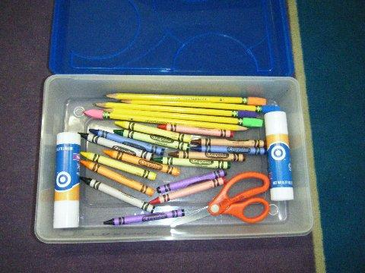
 |  |  |  | Writing Journals will be provided for your child.
 | 2 |  |  | boxes of crayons-regular, not “fat” (8 count-standard colors only)
 | 2 |  |  | black dry erase markers (fat, not thin)
 | 1 |  |  | blunt Fiskars scissors
 | 5 |  |  | SHARPENED pencils with erasers (no more than 5 please!)
 | 2 |  |  | large pencil erasers (no pencil tops, please)
 | 3 |  |  | pocket folders with fasteners (paper) -SOLID COLOR ONLY
 | 3 |  |  | large glue sticks
 | 1 |  |  | large beach-size towel
 | 1 |  |  | large box of Kleenex
 | 1 |  |  | Hand Sanitizer with Pump
 | 1 |  |  | Container of Handy Wipes and Clorox Wipes
 | 1  2 |  |  | Regular size (5x7) Index Cards (1 package)  Reams of Multipurpose Copy Paper (500 sheets per ream)  Rest time mat (4 panels, approx. 19) Please adhere to these dimensions as they need to fit in their cubby!  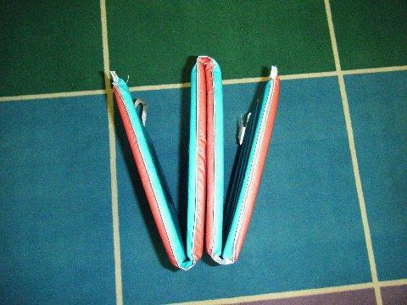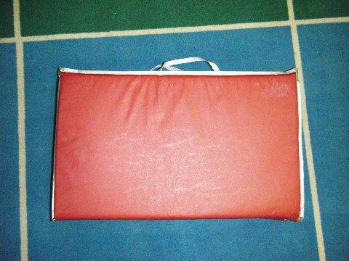
NO BOOK BAG --We will supply each child with a book bag
Children attending Extended Care may bring an extra bag which will be kept in the After Care room

